**Sprint-3**

|  |  |
| --- | --- |
| **DATE** | **12 NOVEMBER 2022** |
| **TEAM ID** | **PNT2022TMID29434** |
| **PROJECT NAME** | **IOT Based Smart Crop Protection System For Agriculture.** |
| **MAXIMU MARKS** | **20 MARKS** |

**PYTHON CODE:**

**import time**

**import sys**

**import ibmiotf.application**

**import ibmiotf.device**

**import random**

**#Provide your IBM Watson Device Credentials**

**organization ="8osflk"**

**deviceType = "cropprotection99"**

**deviceId = "cropprotection99"**

**authMethod="token"**

**authToken ="duiH-8z@4u@JXTmx20"**

**# InitializeGPIO**

**def myCommandCallback(cmd):**

**print("Command received: %s" %cmd.data['command'])**

**status =cmd.data['command']**

**if status=="lighton":**

**print("led on")**

**else:**

**print("led off")**

**#print(cmd)**

**try:**

**deviceOptions={"org": organization,"type":deviceType,"id": deviceId,"auth-method": authMethod, "auth-token": authToken}**

**deviceCli=ibmiotf.device.Client(deviceOptions)**

**#..............................................**

**except Exception as e:**

**print("Caught exception connecting device:%s" %str(e))**

**sys.exit()**

**#Connectandsendadatapoint"hello"withvalue"world"intothecloudasaneventtye"greeting"10times**

**deviceCli.connect()**

**while True:**

**#GetSensorDatafromDHT11**

**temp=random.randint(0,100)**

**humid=random.randint(0,100)**

**data={'temperature':temp,'humidity':humid}**

**#printdata**

**def myOnPublishCallback():**

**print("Published Temperature=%s C" %temp,"Humidity=%s %%" % humid,"to IBMWatson")**

**success=deviceCli.publishEvent("IoTSensor","json",data,qos=0,on_publish=myOnPublishCallback)**

**if not success:**

**print("NotconnectedtoIoTF")**

**time.sleep(1)**

**deviceCli.commandCallback=myCommandCallback**

**#Disconnectthedeviceandapplicationfromthecloud**

**deviceCli.disconnect()**

**OUTPUT:**

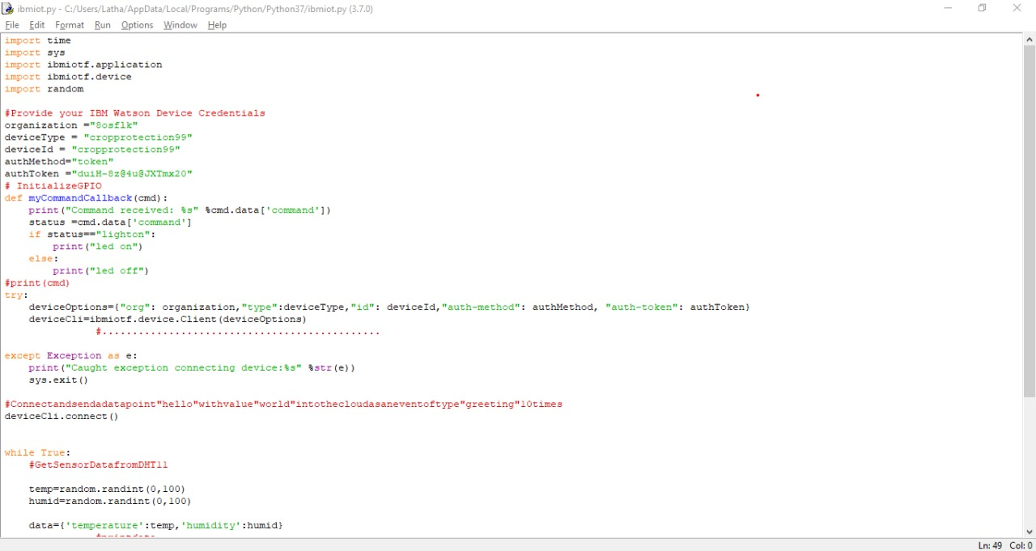

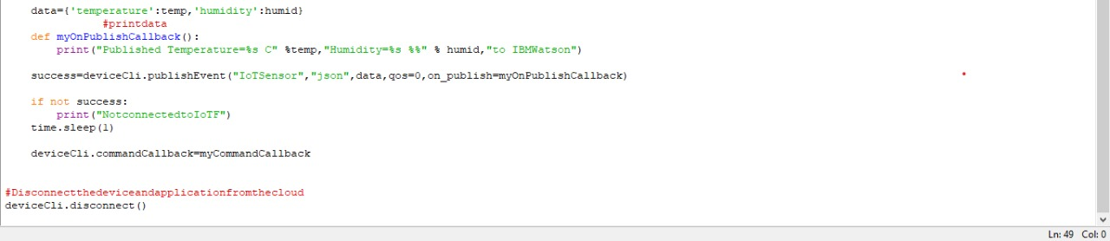

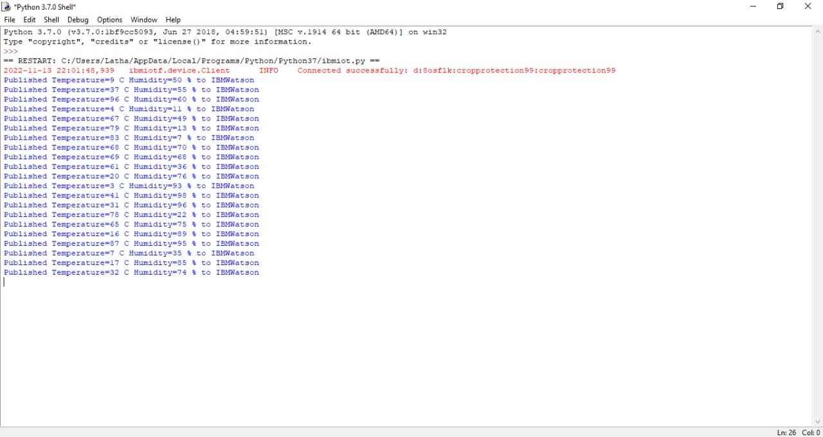

**IBM WATSON IOT PLATFORM:**

